**Author name- Harwinder Kaur**

**NAVNEET Kaur Bhatti**

**Rupneet Rupa**

**Student id-100360536**

**100368904**

**Assignment – 3**

**Course number –info 1113**

**Section number-s10**

**Instructor name-dr. abhijit sen**

**Date-november 22, 2018**

**Web url-** [**https://sites.google.com/view/batthfunwithappscom**](https://sites.google.com/view/batthfunwithappscom)

[**https://sites.google.com/view/navneetbhatti**](https://sites.google.com/view/navneetbhatti)

[**https://sites.google.com/view/rupneet**](https://sites.google.com/view/rupneet)

**Github url-** [**https://github.com/HarwinderBatth/testProject**](https://github.com/HarwinderBatth/testProject)

[**https://github.com/navneet131/navneet.git**](https://github.com/navneet131/navneet.git)

Table of Contents

Title

Introduction2

Functions3

**Use-case diagram4**

Use-case description5

Comments

Conclusion6

**Introduction**

The project is about a tracking app designed in order to track a device and any person using that device .It’s main purpose is to find the lost devices and in order to track a lost person and to help the person in an emergency.

**Functions**

Tracking the location

This app will track the user’s location and send a message to the nearest tracking system or any contact or person specified by the user in case of emergency. The tracking system also sends an emergency alert to the nearest safety department as well. Moreover, one can find his/her lost device.

**Use case diagram**

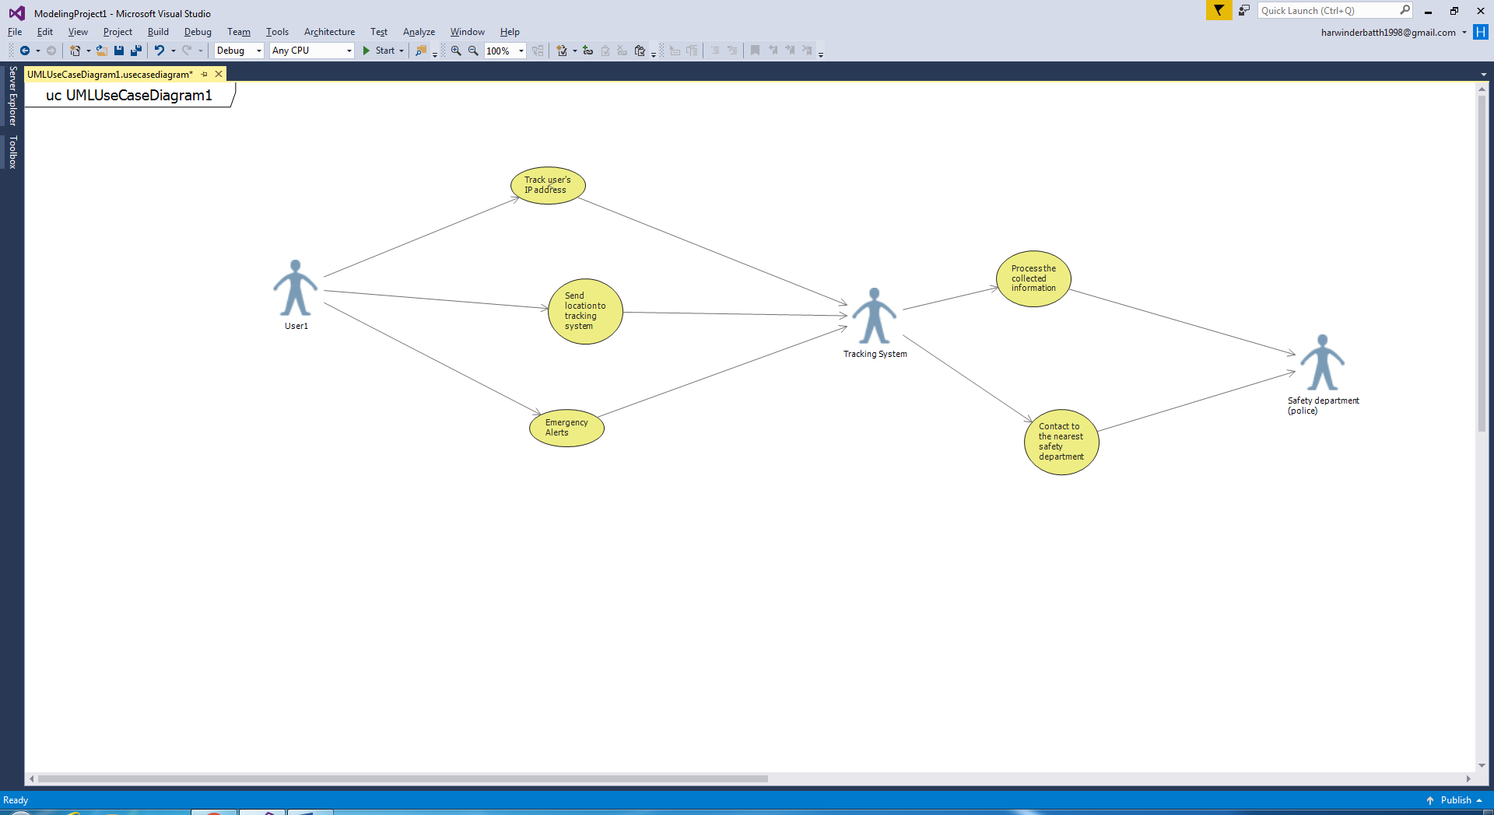

**Use Case Description**

|  |
| --- |
| Use Case Title: Be Found |
| Primary Actor: User 1 |
| Level: Kite |
| Stakeholders: Tracking System and user’s contacts |
| Precondition: App should be in person’s phone |
| Minimal Guarantee: Track the nearest location |
| Success Guarantee: Provides exact location and alerts |
| Trigger: Just single tap on app or by clicking the power button |
| Main Success Scenario:   * User presses the power button. * App will send the notification of the location to the tracking system and triggers emergency alerts as well. |
| Extensions: Can work without Internet. |
| Primary Originator: Harwinder Kaur |
| Reviewer: All Group Members |

**Comments**

I tried to make use case diagram in visual studio 2017 but I was unable to do that then I tried to download visual studio 2015 on my laptop that time I also faced some problems.

**Conclusion**

In conclusion, this app will be very helpful in emergency situations specially for women safety. Moreover, it becomes easier to find the lost devices.